Step 1:

Step 2:

The NOT NULL constraint being applied to category_id column works to create the rule that no missing or empty values are in the category-id column. The category_id column also has the PRIMARY KEY constraint applied to it. This rule is important because the category_id column is the primary key which is used to find specific information and means that this column has a different value for each row in the table.

Step 3:

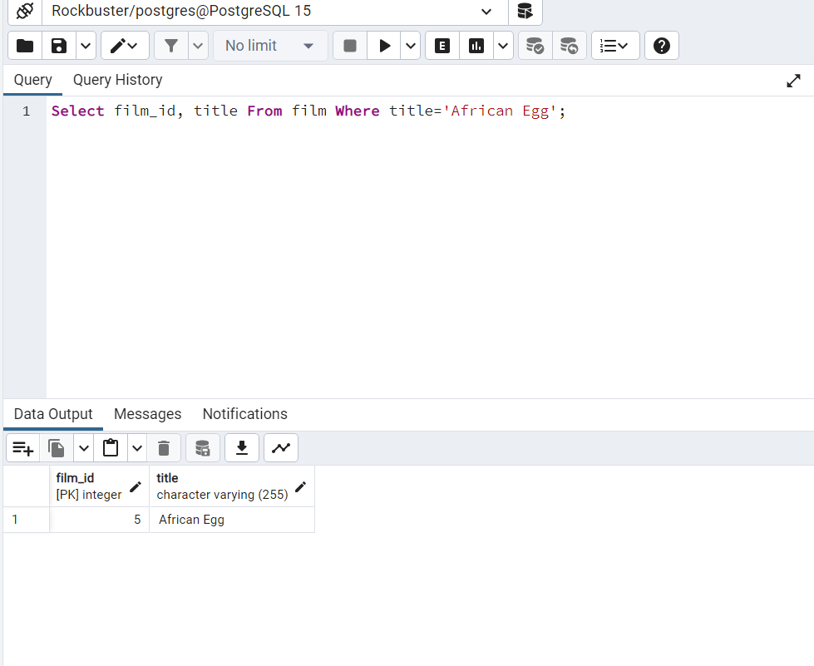

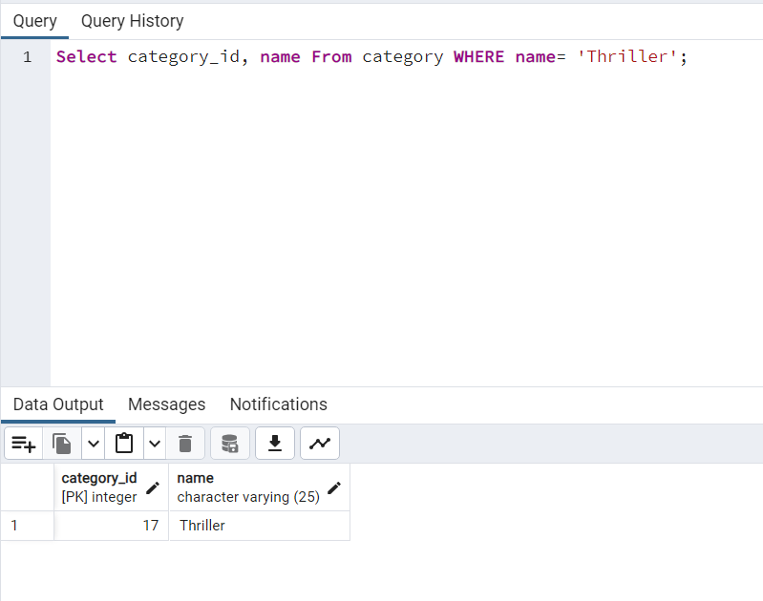

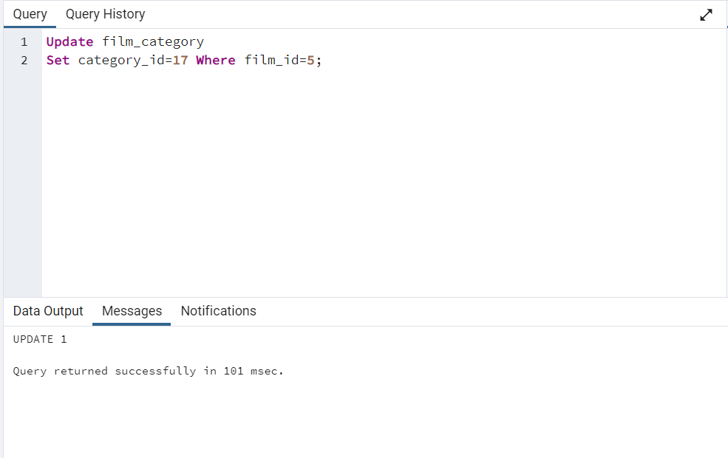

Step 4:

Step 5:

If I used excel rather than SQL to complete the processes above it would have taken more time to complete the process. This is because there wouldn’t be a single command that can be used in excel to complete these steps so I would have to manually delete and ctrl f to find values. However if I was working with a smaller set of data then excel would be preferred.